

Foundations of Programming

Lab Assignment No. : 03

PROBLEM STATEMENT:
Write a program in C to generate multiplication tables for a given number.
OBJECTIVES:
- To understand the use of looping statements in C.
- To generate multiplication tables using loops.
- To improve program logic and execution flow understanding.

THEORY:
A loop in C is used to execute a block of code repeatedly until a specific condition becomes false. Loops help reduce code repetition and make programs more efficient.
There are three main types of loops in C:
- for loop – Used when the number of iterations is known in advance.
- while loop – Executes a block of code while a condition is true.
- do-while loop – Executes the block at least once and then checks the condition.
In this program, a loop is used to generate the multiplication table of a number. The user enters a number and the loop runs from 1 to 10, multiplying the given number with the counter value in each iteration and displaying the result.
Loops are important because they simplify repetitive calculations and improve program readability and efficiency.

ALGORITHM:
S1: Start
S2: Read a number 'n'
S3: Set counter as 1 and while counter <=10, Calculate n * counter and store result in answer variable
S4: Display answer.
S5: Stop

FLOWCHART:
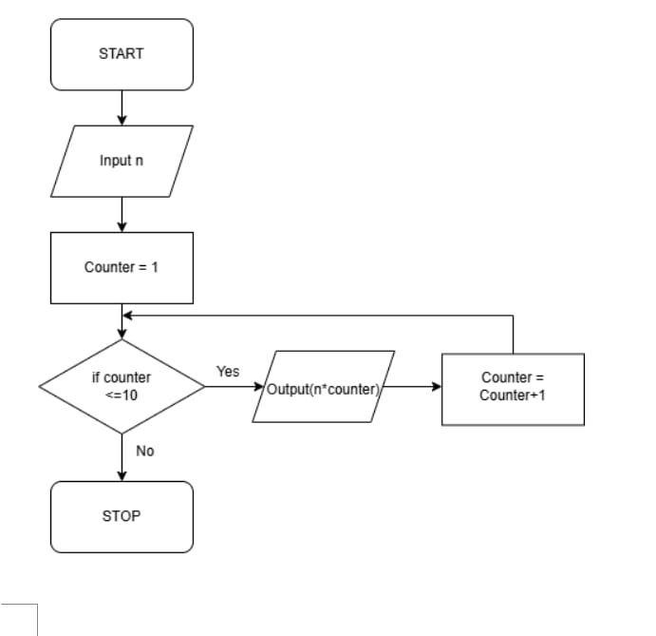

Type Program (Multiplication table)

PLATFORM:
Linux

CODE:
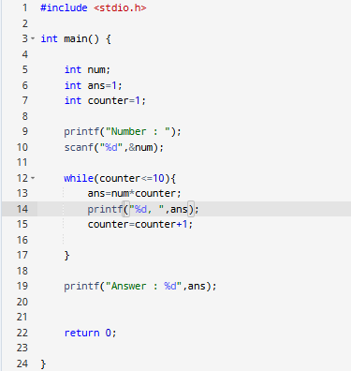

INPUT & OUTPUT:
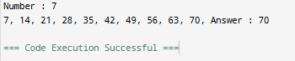

SAMPLE INPUT:
2
SAMPLE OUTPUT:
2, 4, 6, 8, 10, 12, 14, 16, 18, 20

CONCLUSION:
Thus, the menu driven program in C successfully performs basic arithmetic operations using switch–case statements.

FAQs:
- Which loop is best suited for generating multiplication tables?
- What is the role of loop initialization?
- Difference between for loop, while loop and do while loop?
- Can a do–while loop be used to generate multiplication tables? Explain.
- Why is the do–while loop called an exit-controlled loop?

